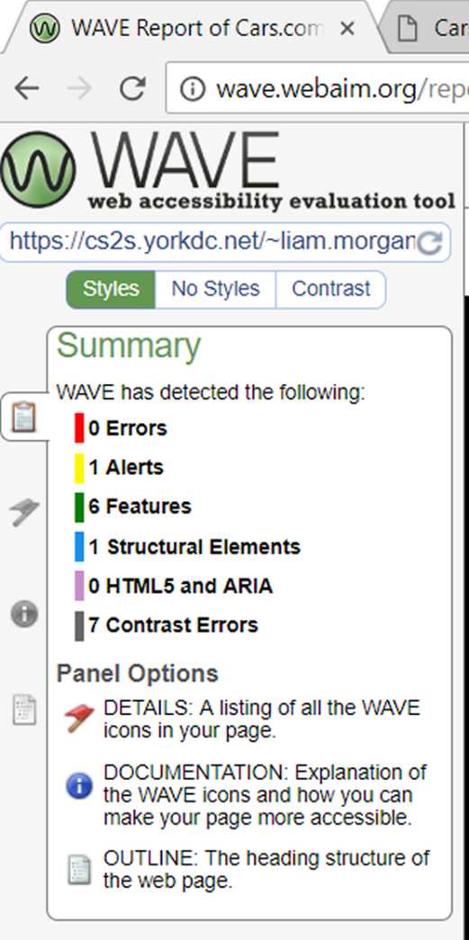

Only the usernames and passwords in the read.txt file work for the login system its formatted so that its: Username | password

All information has obtained from Wikipedia

All images are from https://wallpaperscraft.com/catalog/cars